LAB REPORT – 7
Binary Cell for RAM

NAME : Basireddy Khyathi Sri
ROLL NO : 2023102065
GROUP : 6
TABLE NO : 3

Objective:
To implement and verify the operation of a Binary cell for
RAM based on RS flipflop.

Electronic Components Required:
• Breadboard
• power supply
• Input switches
• output display pin
- IC 7411, IC 7404, IC 7402 (NOR gate)[But in the lab we have used IC 7432

Reference Circuit:

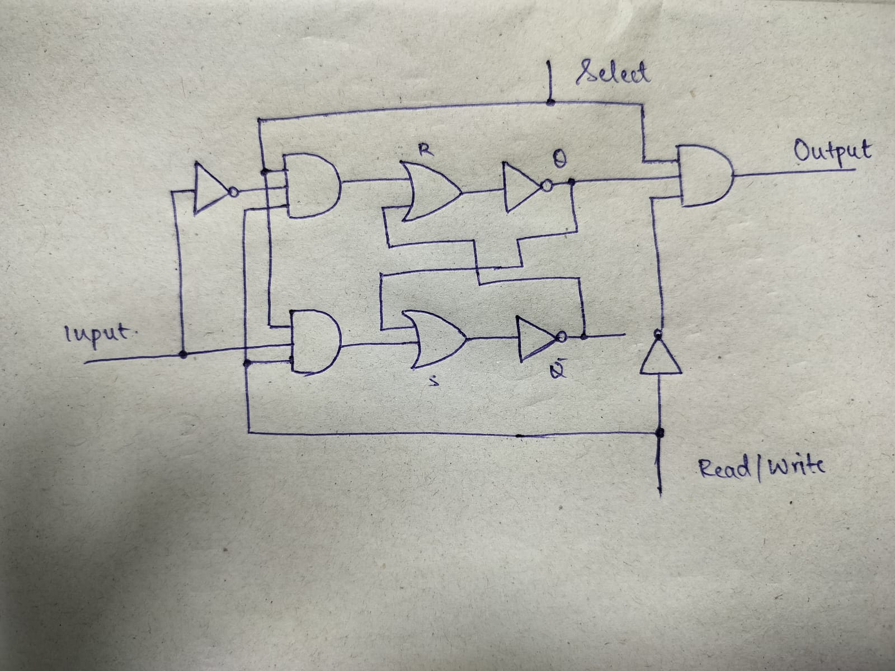

TinkerCad Simulation:

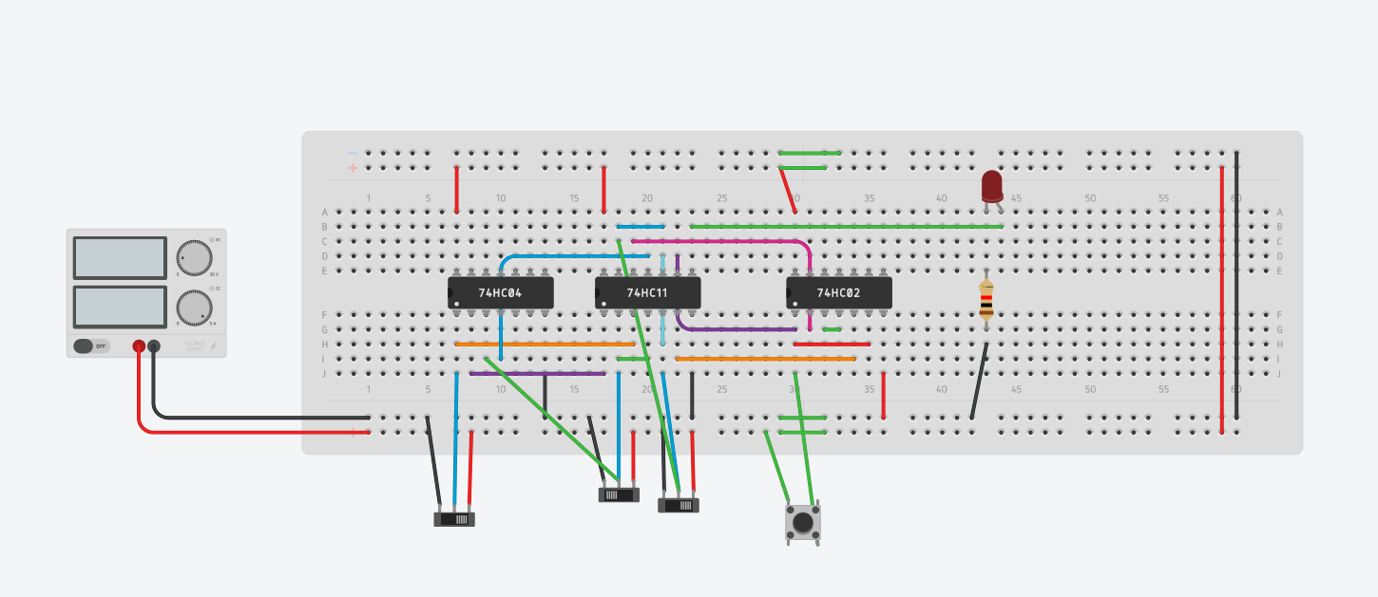
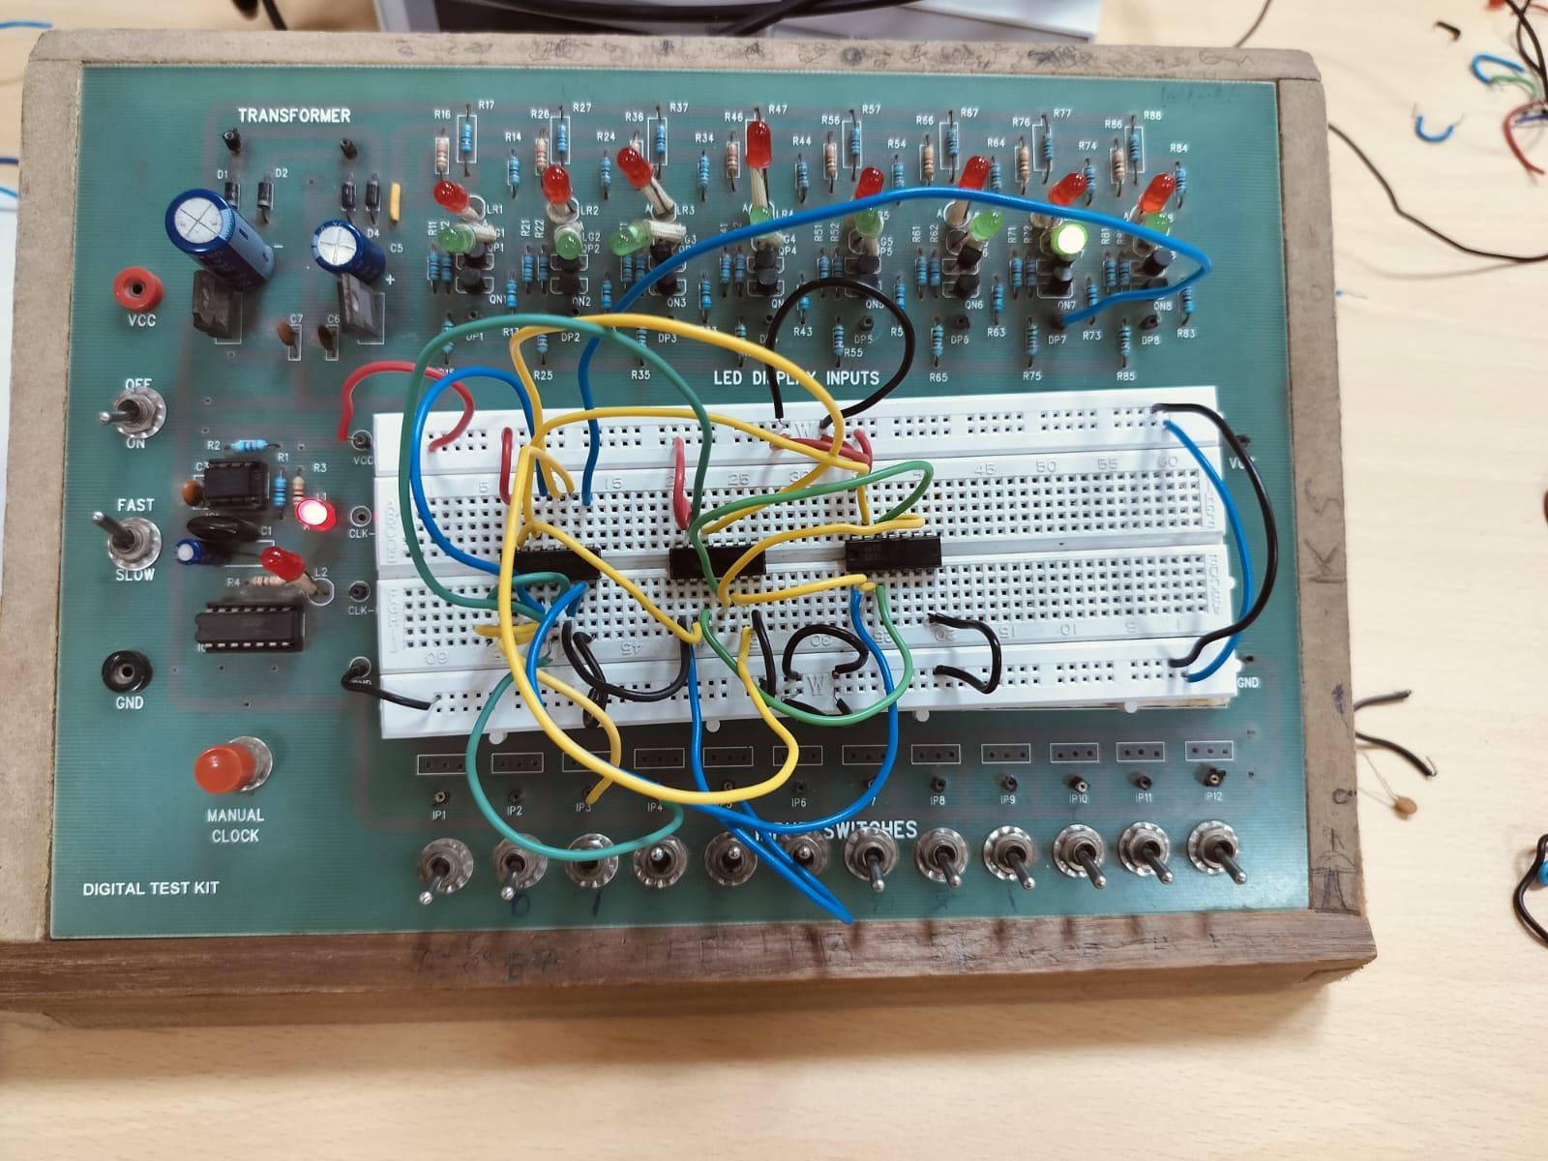

Procedure:
1. Power up the breadboard and place the ICs on it. Now, we
have to build a circuit involving the SR flip flop.
2. The circuit can be built by connecting wires, gates according
to the below reference circuit.
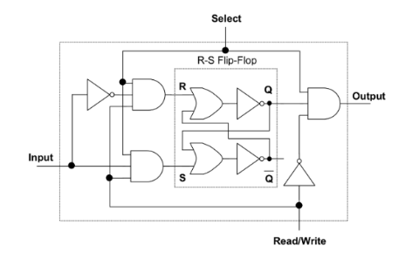

3. Through manual input switches, we provide inputs for Select,
Read/Write, and Input. This binary cell circuit only operates
when the Select line is high.
4. Finally, we connect the output to one of the output display
pins or an LED.

Observation:
We observe the following by these series of operations.

SELECT | READ/WRITE | INPUT | OUTPUT
0 | X | X | 0
1 | 1 | 1 | 0
1 | 0 | X | 1
1 | 1 | 0 | 0
1 | 0 | X | 0

X - In every state (0 / 1), the output is independent of the
input.
Only when Select is HIGH, the circuit will work.

Conclusion:
Using an SR flip-flop, we constructed a RAM binary cell and
tested its functionality.

TinkerCad Simulation Link:

https://www.tinkercad.com/things/4uSHISRvYAG-binary-cell/editel?sharecode=1TmNpnC9_yeFoPIg3d1uybeGQmvjVoR03_GNDgBLTlg

